**Eastern Region (ER) – Regional Functional Committee (25-27)**

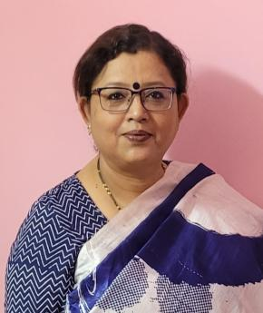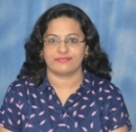

Smt. Swagata Sen Roy

President, WIPS (ER)

Additional General Manager (Corporate Communication)

Garden Reach Shipbuilders & Engineers Ltd.

Swagata Sen Roy is an Electrical & Electronics Engineer with an MBA in Marketing. She has 30 years of professional experience in the field of Marketing, Corporate Planning & Corporate Communication. At present, she is leading the Corporate Communication Section as AGM (CC) in GRSE.

She has been associated with WIPS since the year 2012 as a GRSE WIPS Life Member, took on as GRSE WIPS Coordinator from the year 2016 & Eastern Region Executive Committee Member since the year 2018, prior to taking on the role of WIPS Secretary, Eastern Region in 2023. She was elected as the President, WIPS (ER) in Feb 2025.

Smt. Neha Dugar

Vice President WIPS-ER

Senior Manager (Internal Audit)

Indian Oil Corporation Limited

Neha Dugar is a qualified Chartered Accountant and Company Secretary. She joined Indian Oil Corporation Limited (IOCL) in April 2010. With over 15 years of professional experience spanning across Finance and Audit Functions, she is now posted as Senior Manager (Internal Audit) ERO IOCL.

Neha Dugar has been an active member of WIPS since 2012. She has been an EC member of the Eastern Regional Executive Body (REB) since 2016. After serving as Treasurer WIPS ER for the Term 2023-25, she is currently holding the post of Vice President WIPS-ER for the Term 2025-27.

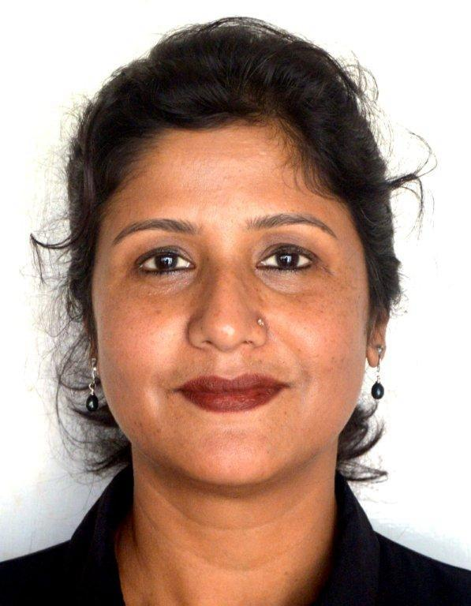

**Ms Ranjana Chakravorty**

**Secretary, WIPS -ER**

**General Manager (Planning, IGGL)**

**Numaligarh Refinery Limited**

**Ranjana Chakravorty, BE(Electrical) , passed out from Assam Engineering College, Guwahati  and joined Numaligarh Refinery Limited in 1997. She is an MBA( Executive) from Gauhati University. Presently she is holding the position of General Manager (Planning) on deputation to IGGL ( Indradhanush Gas Grid Limited).**

**A founder member of WIPS-NRL Chapter, she is actively involved with various activities of the Forum since 2005. She was an executive member of WIPS-ER during 2023-25 and presently holding the portfolio of Secretary, WIPS-ER for 2025-27.**

**Smt. Rekha Pandey**

**Treasurer WIPS-ER**

**GM (HR)**

**Central Coalfields Ltd.,**

**Rekha Pandey is General Manager (HR) at Central Coalfields Limited. She is a Law Graduate. She has rich experience of 31 years in different facets of HR. She is dynamic leader exhibiting qualities like courage, passion, empathy and vision.**

**She is multitasker, currently holding 3 leadership positions simultaneously, Treasurer, WIPS-ER, Secretary, NIPM Ranchi Chapter and Vice-President, ISTD, Ranchi Chapter. With a keen eye to detail in organising and managing people, she has been leading the team in organising Coal India Ranchi Marathon since 2023, which sees participation from over 10,000 runners from across India. She believes in duty with devotion. The run has been graced by renowned female personalities such as Premlata Agarwal, P T Usha, Mary Kom and others.**